On a bus throught the Atacama desert. Luxurty travel for 7 hours for about 4 quid.
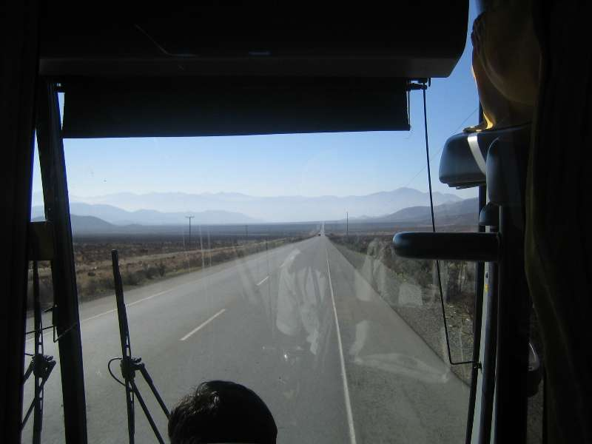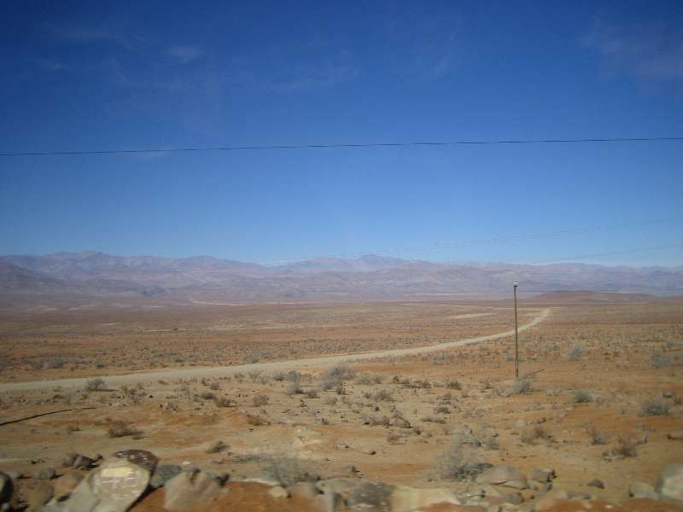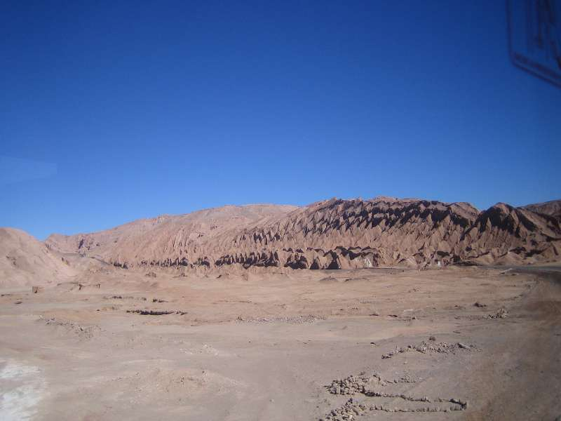

Hostel in San Pedro De Atacama. Had to lite the boiler with a match to get hot water,.
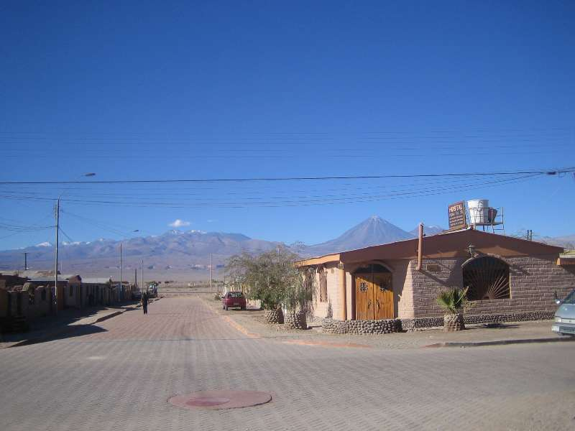

Teamed up with 2 Ozzie doctors, Lynn and Simona. 17km bike ride to watch sunset over Valyy De La Luna.
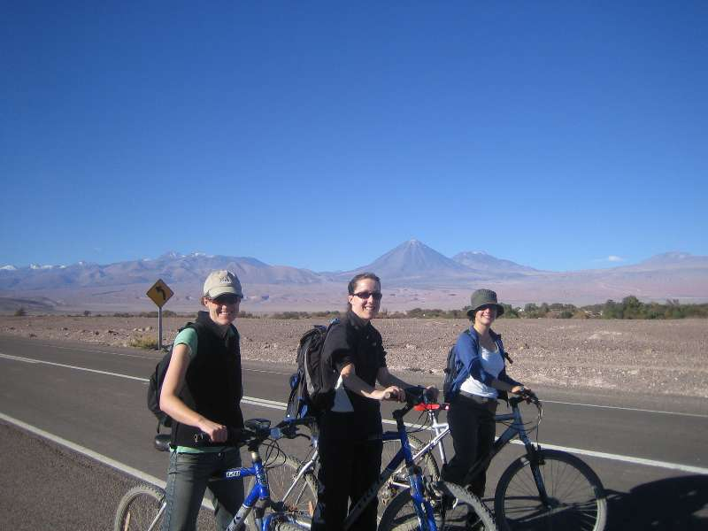

The white staff is SALT not ice.
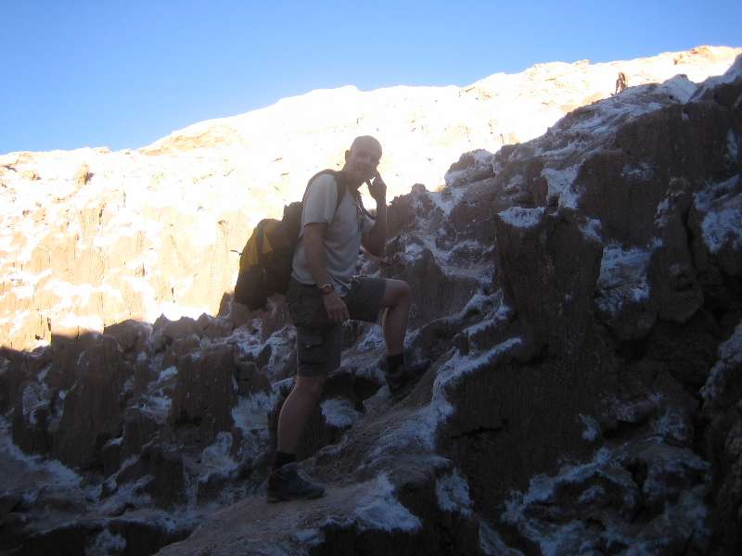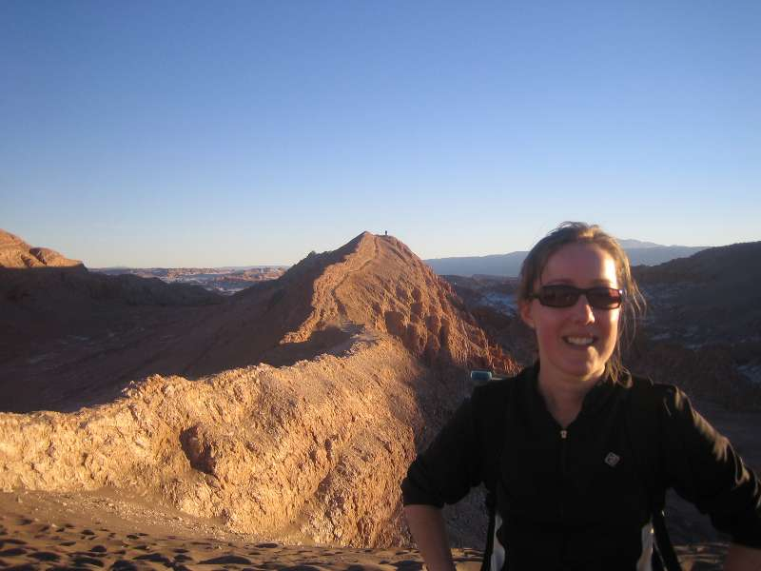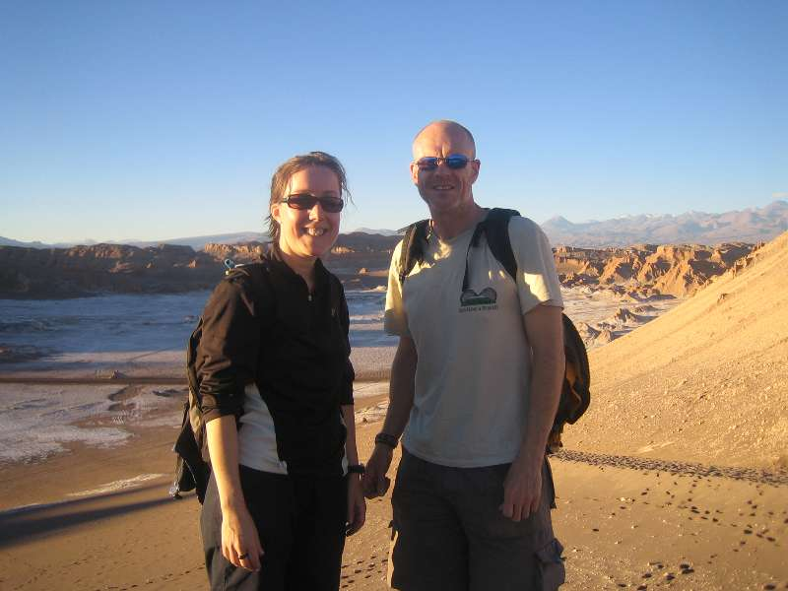

Next day stared 3 day 4WD trip through Bolivia. Notice the plush customs building.
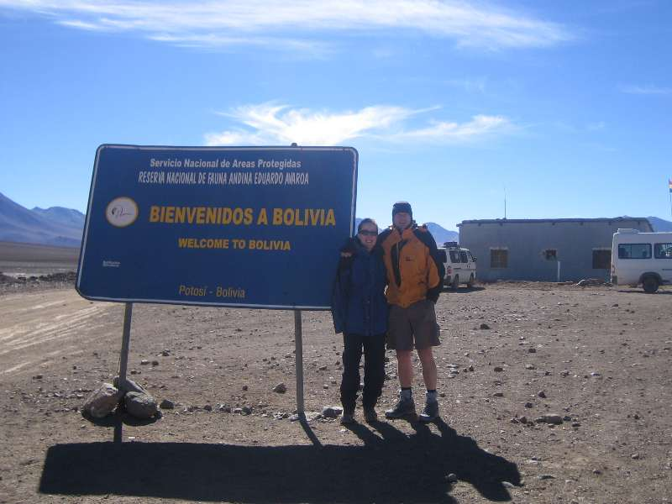

Our guide Roy.
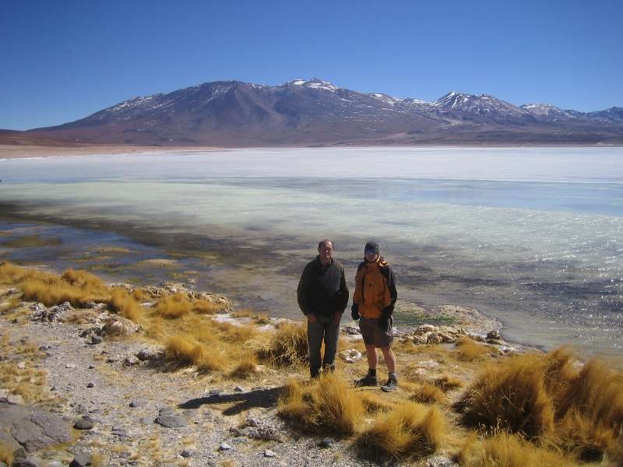

Laguna Verde (Green lake)
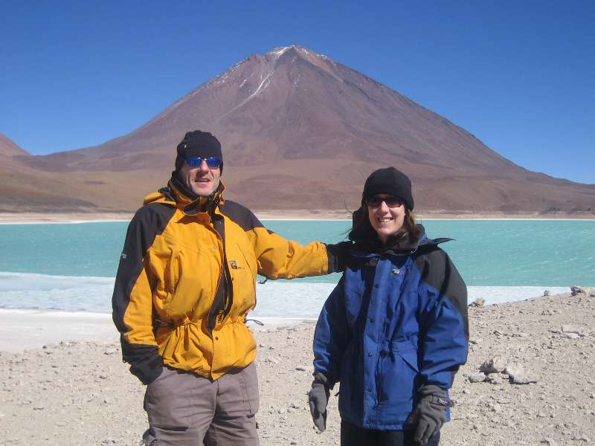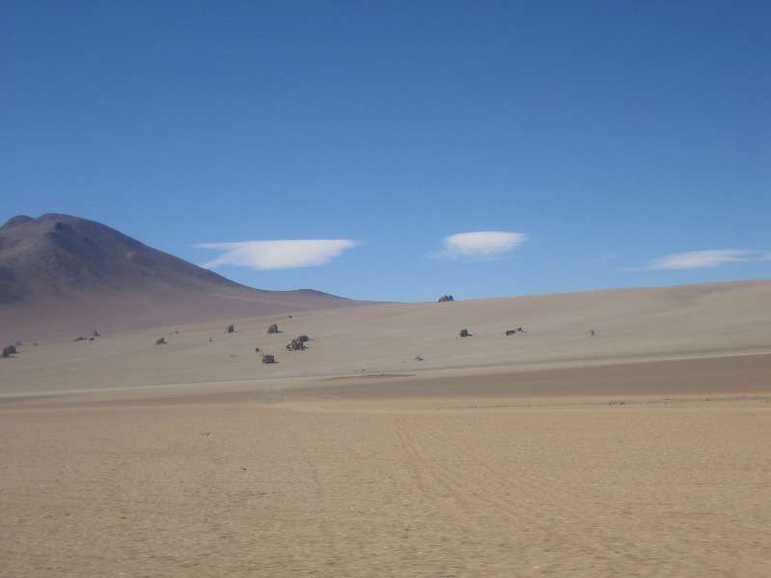

A hot spring, no trunks. Outside temp 2deg C.
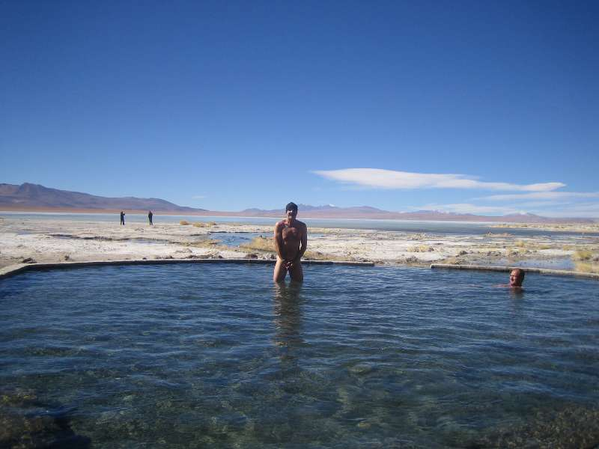
Muddy geysers.
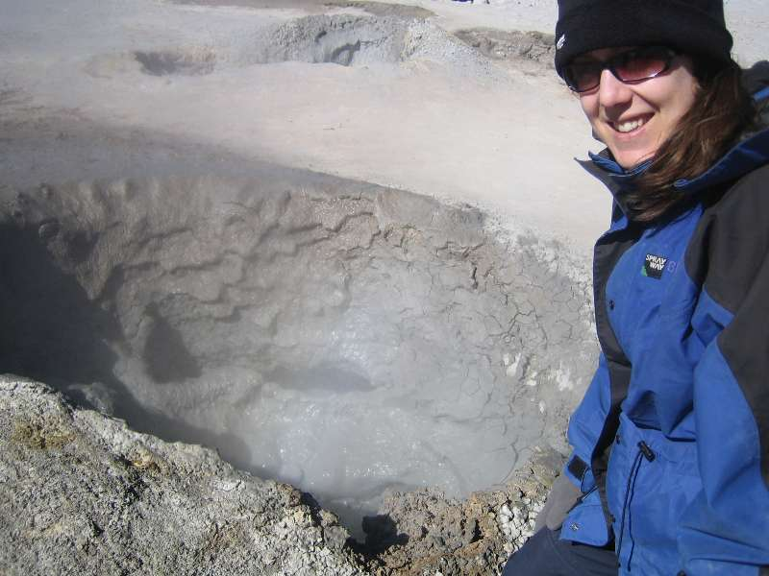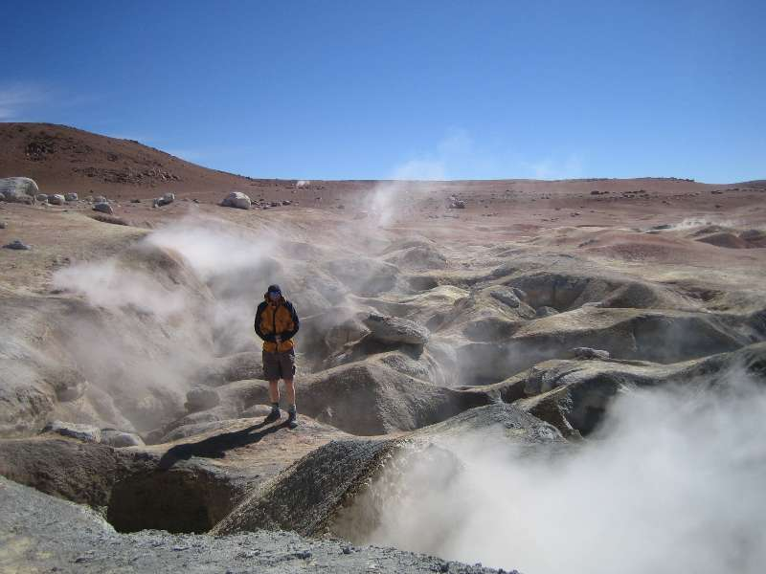

Don´t disturb the flamingos.
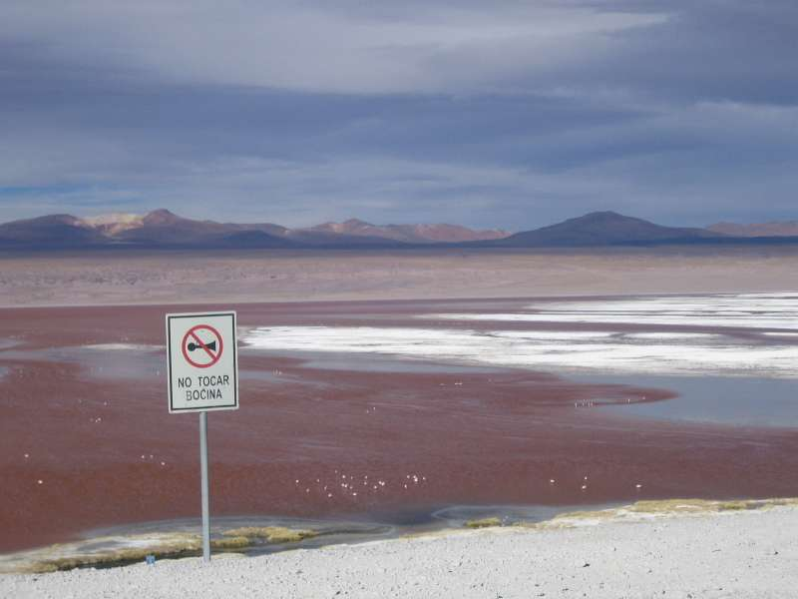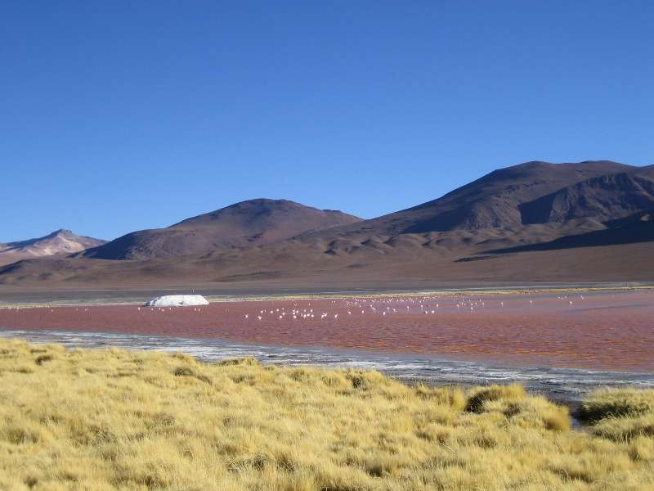

Wils Llamas.
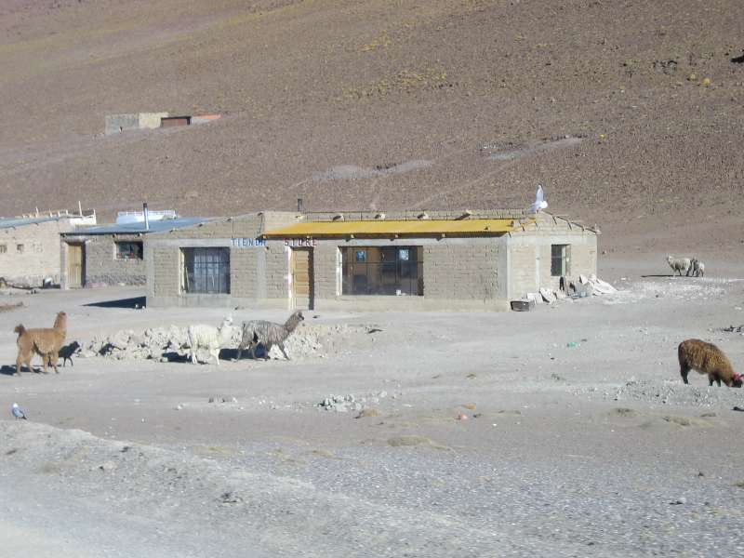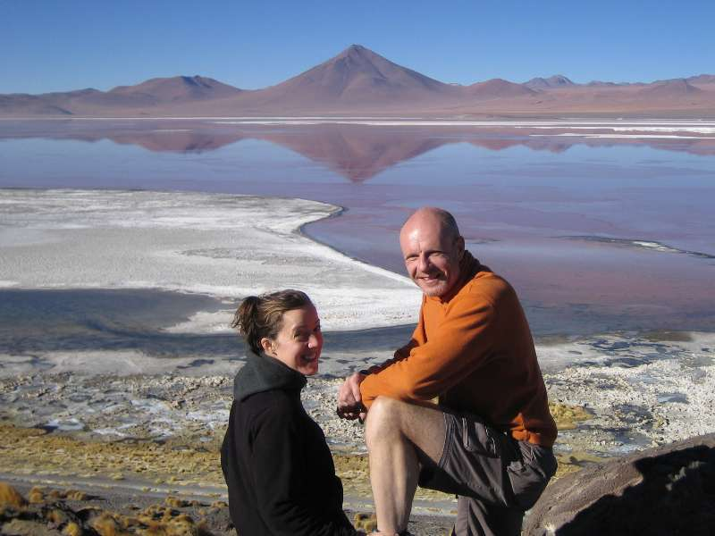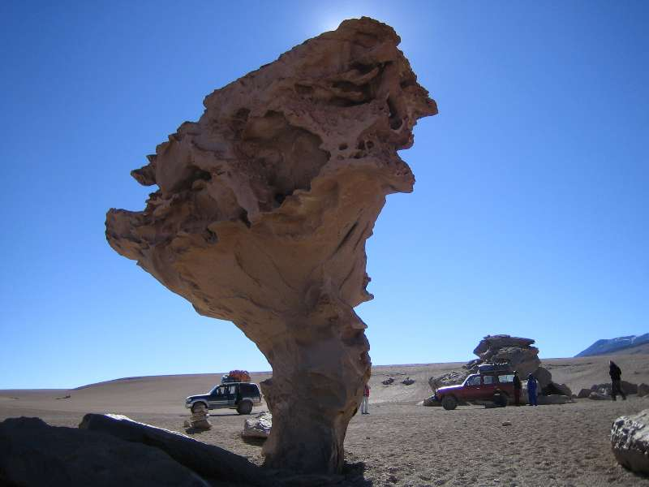

A wild rabbit thing. Not scared of humans as they rarely see them.
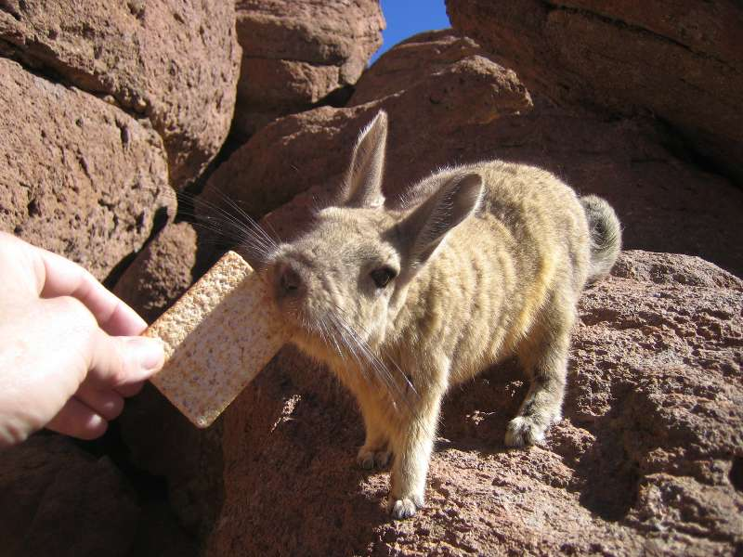

Green staff not moss, but lumps of hard smooth wooden stuff used for fire wood.
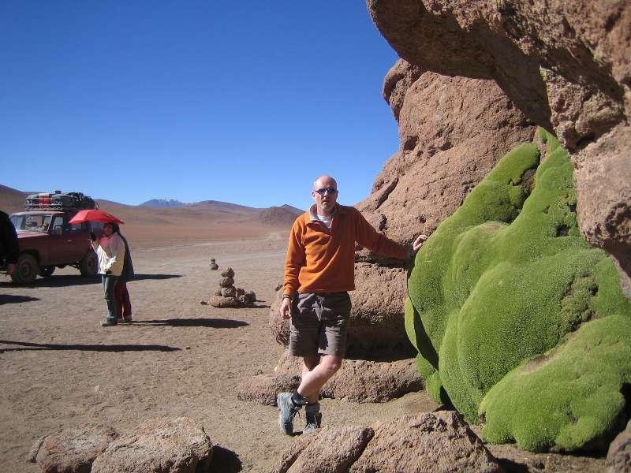

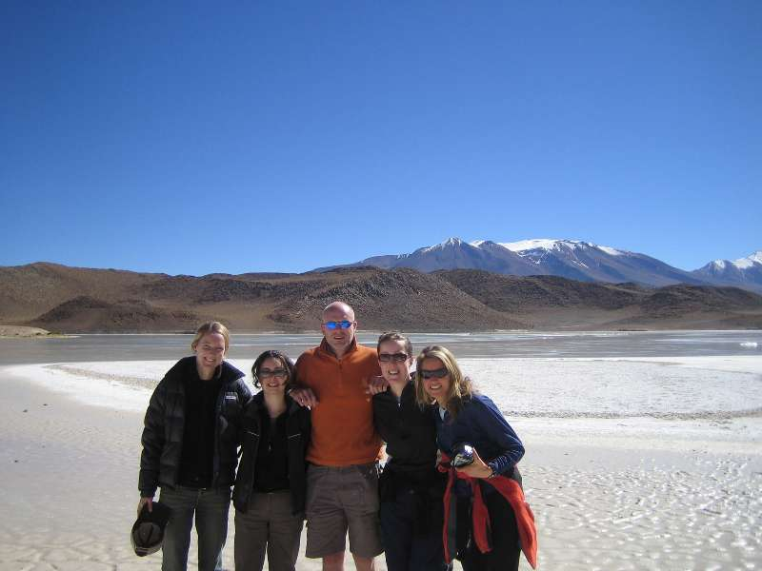

Flamingoes eating red algae. White stuff is borax.
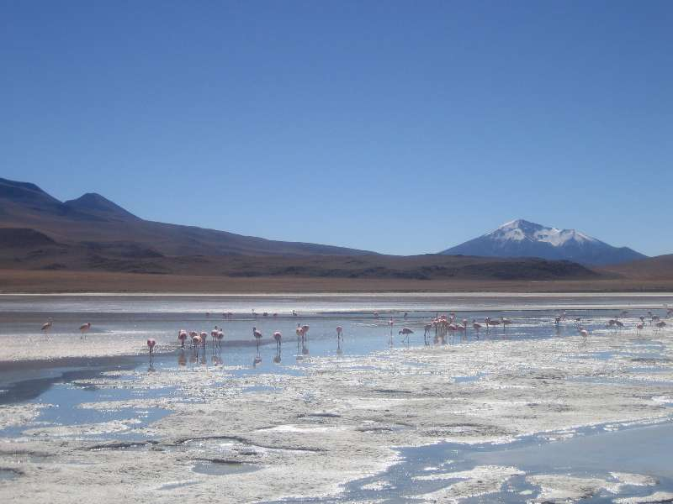

Desert fox if you look close.
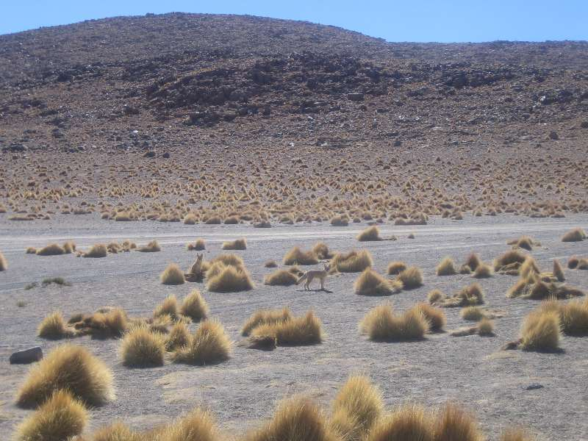

Active volcano, you can just see sulphurous cload emanating.
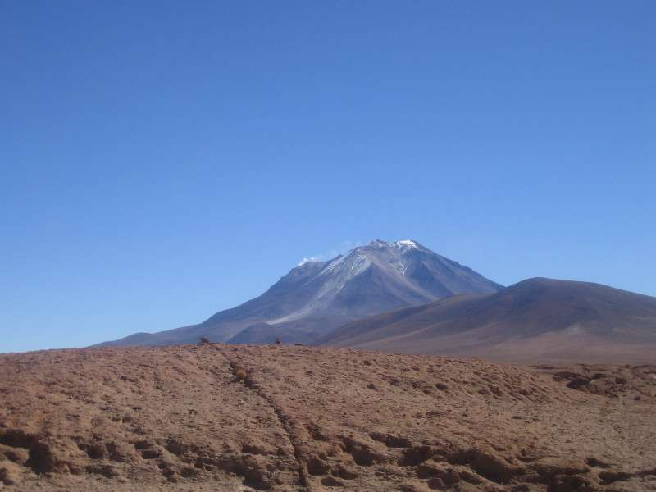

Salt Hotel on edge of salt lake.. A hotel made of salt. Altitude 4400m, and -10deg C overnight.See cactus on hill.
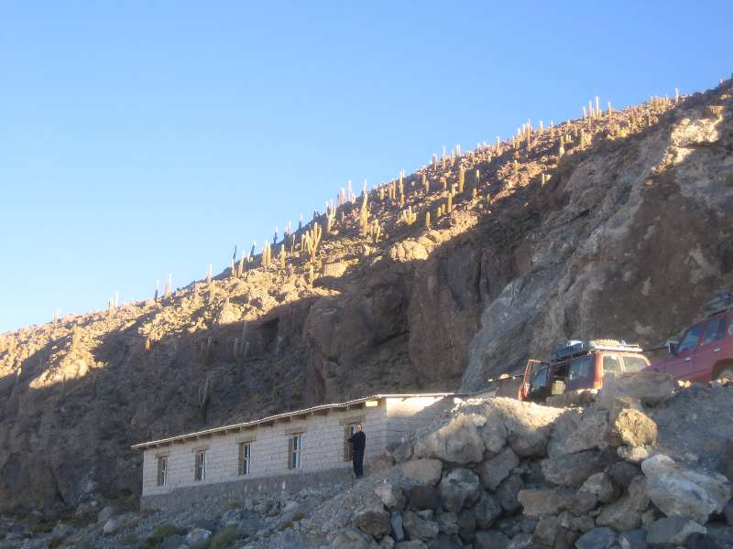
Road out over salt lake
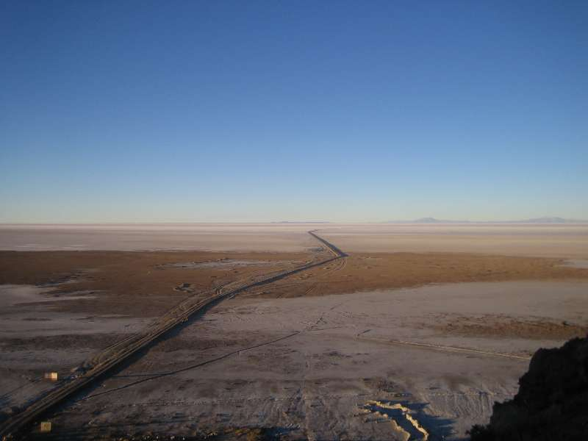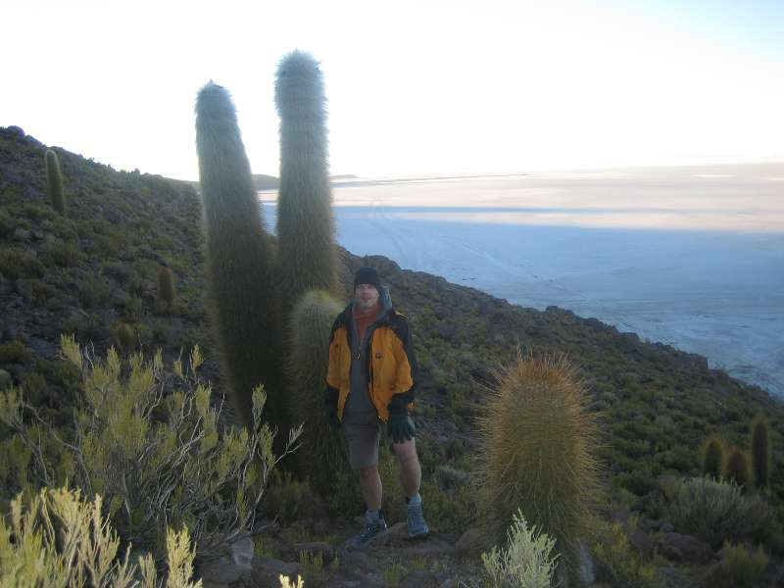

Salt hotel staff and our 4WD drivers.
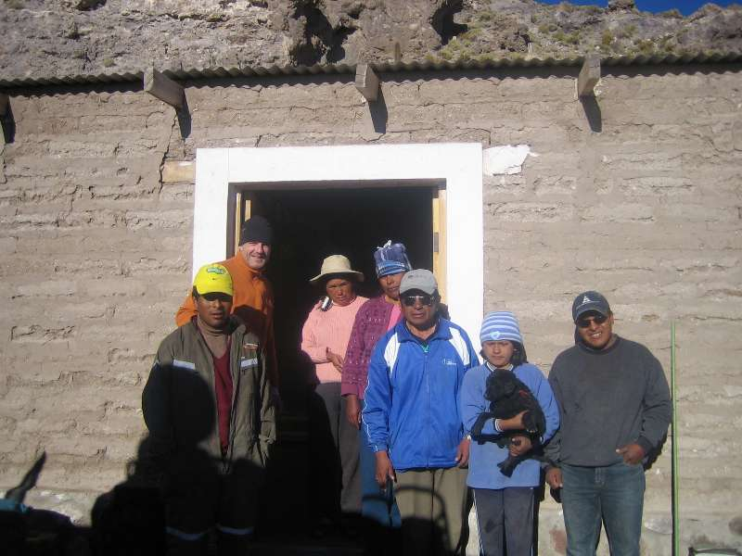

Inva Wadi Island, usually mistakenly known as Fish Island. 200m square, 50 m high, surrounded by salt pane with is biggest in world (200km square-ish). Alt about 3600m I think. Covered in cacti, the type they have in speedy Gonsales cartoons. Some are 200 yrs old.
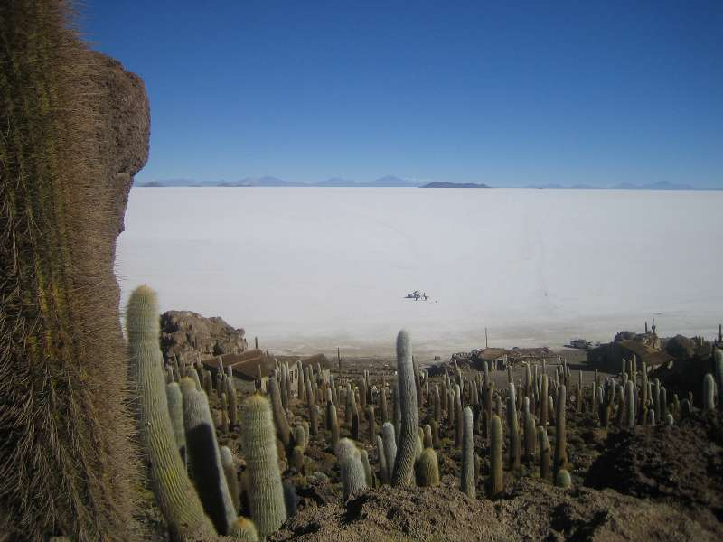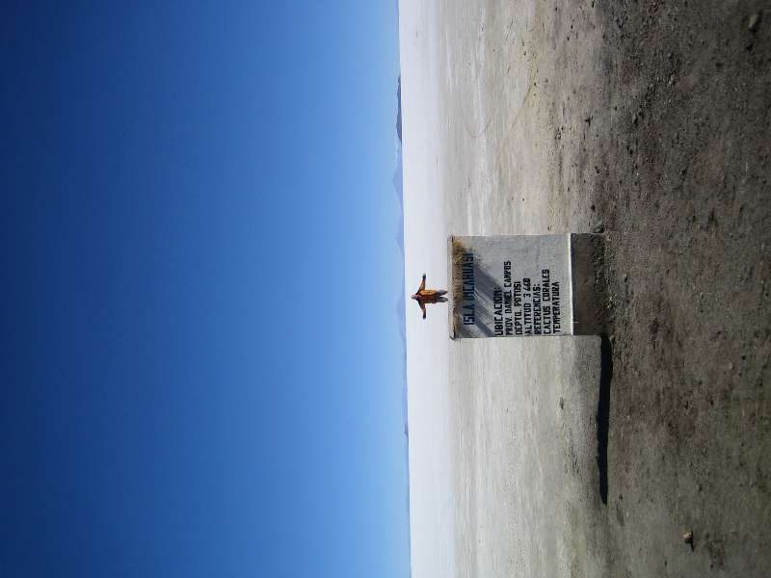

Attempted artisic photos on salt plane.
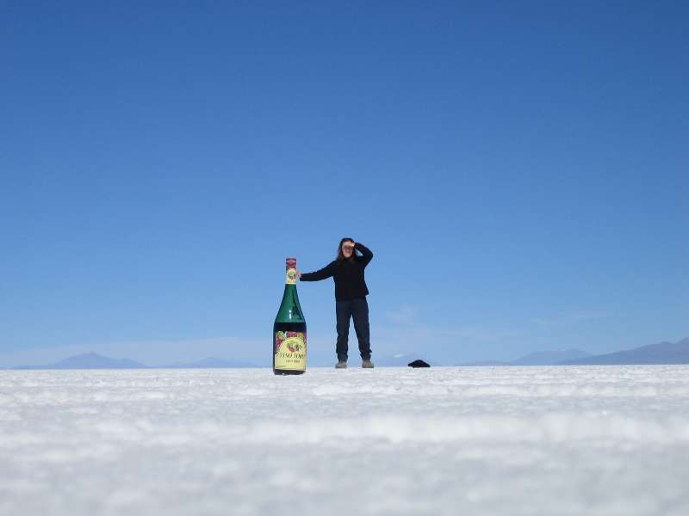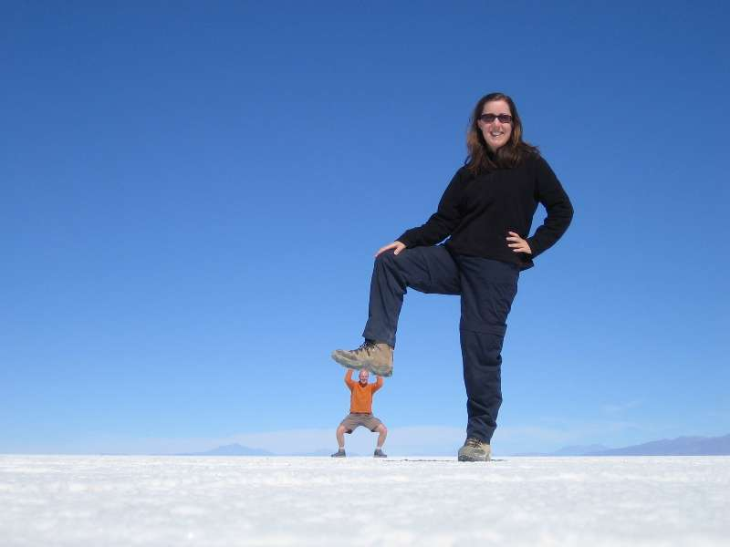

Salt hervested (top 2 inches scraped off) for selling.
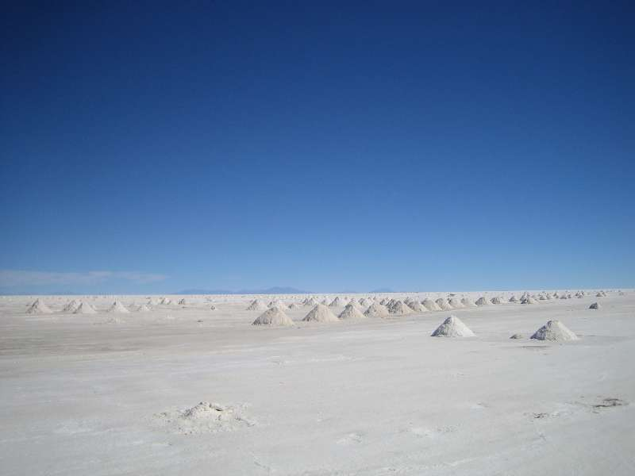

4WD couldn´t drop us IN Uyuni as planned, as nacional elevtions made road travel illegal. So had to be dropped 2km out of town and walk in. Some othet backpackers said their driver drove into to town and was arrested and locked up. Scary.
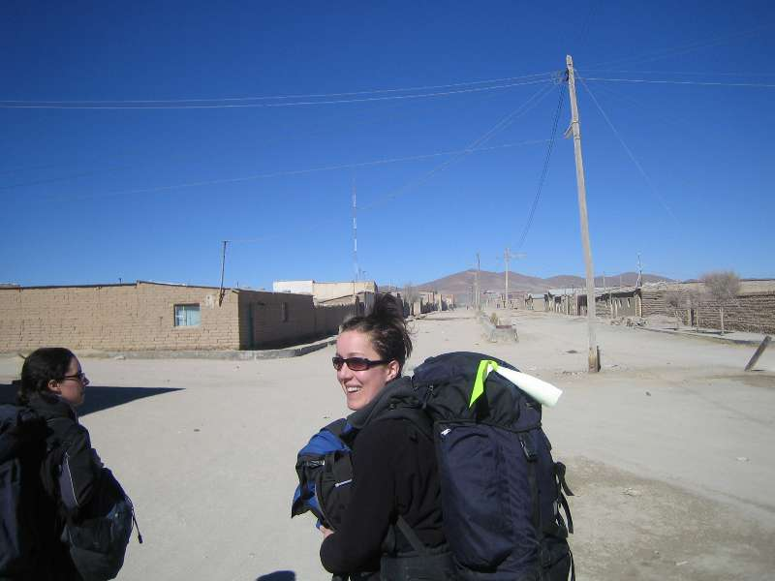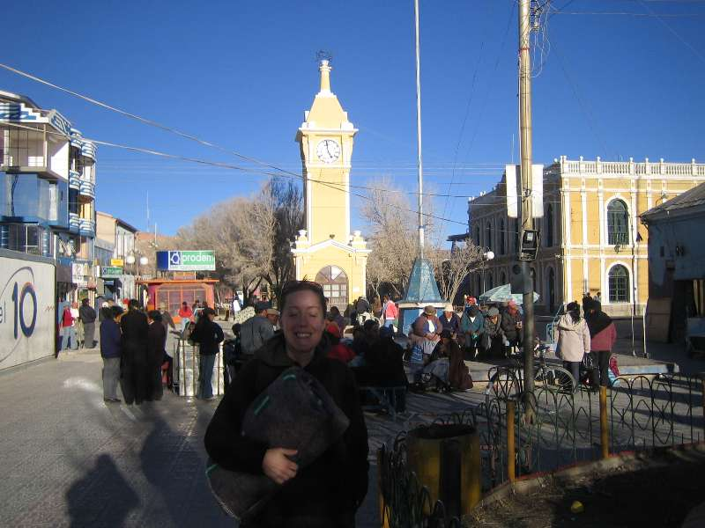

Bus from Uyuni to La Paz 11 hours overnight. Becaause of illegal transport problem, had to get illegal bus out of town, by walking 1km out off town to dark alleyway to meet bus. Journey was 90 bumpy desert road, often slowed to 1st gear for potholes. All clothing and a thick blanket still freezing cold.

Some bowler-hatted Bolivain women (behind Nic)
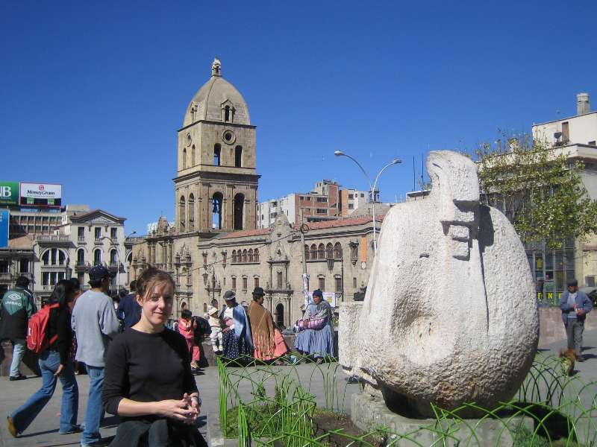

Witches market. Look close for Llama foetuses.
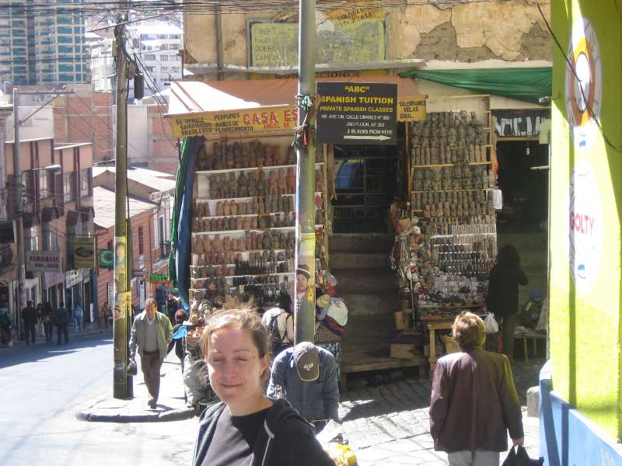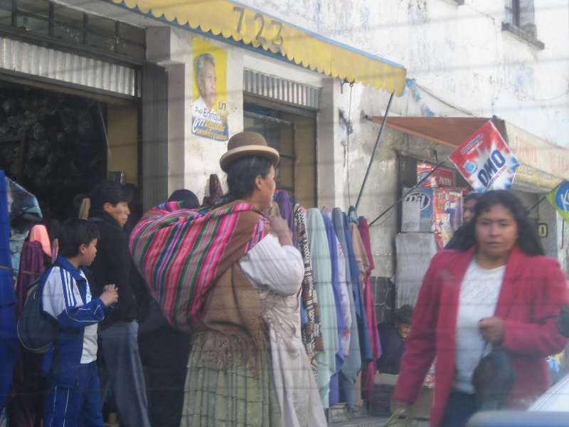

Leaving La Paz, highest city in world 3500m.
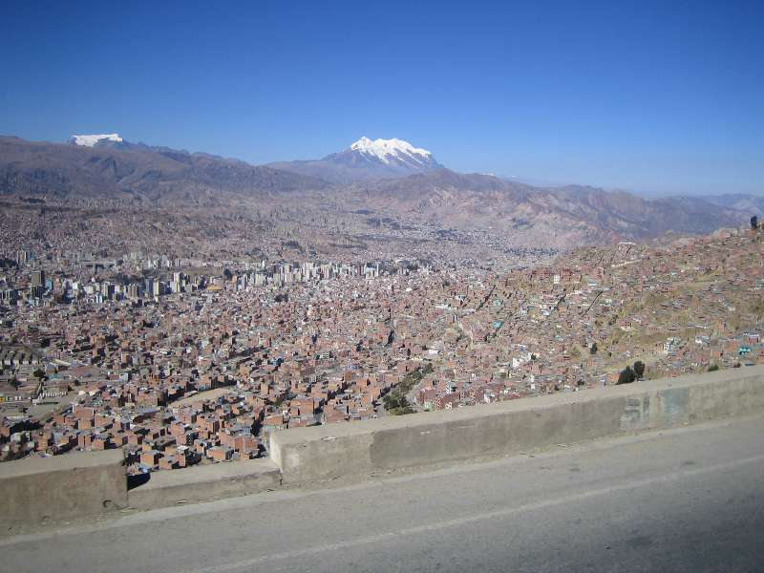

Aound lake Titicacac.
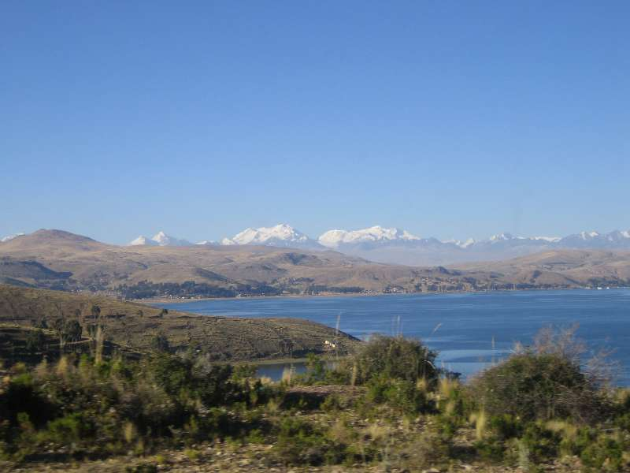

Buses have to take a “ferry”. Pic taken from our bus on similar boat.
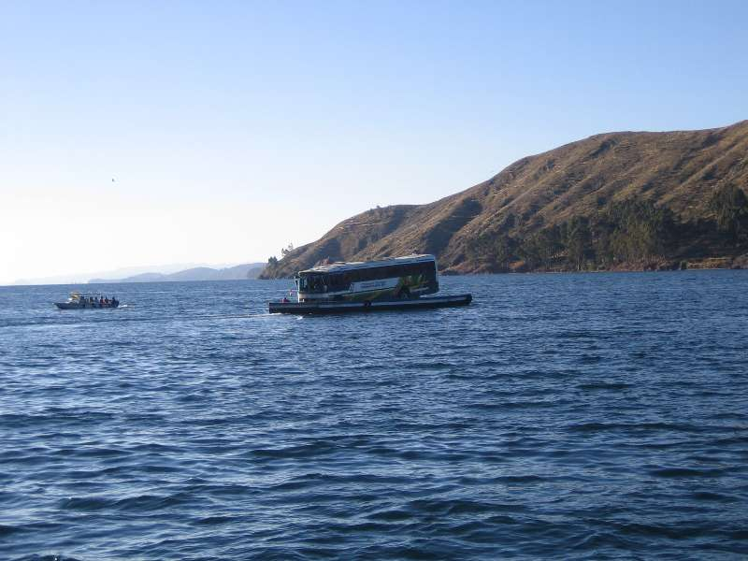

Arrival in Copacabana (not the real one in Brazil). Health & safety don´t do showers here.
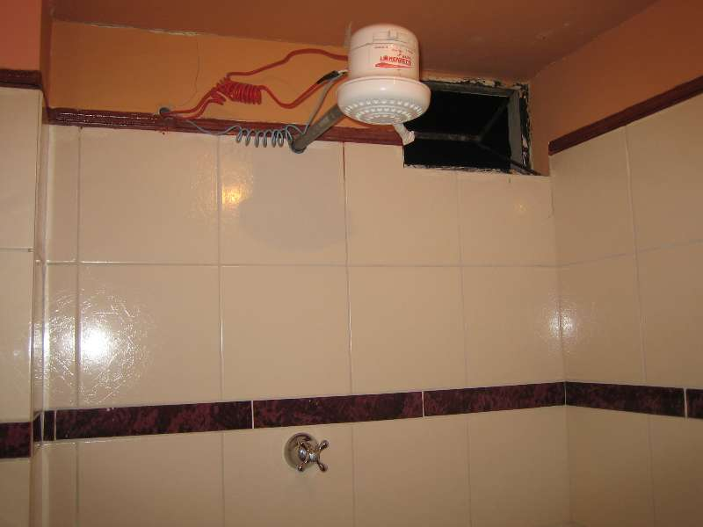

Had to pay this woman for privo f taking photo, still wouldn´t smile.
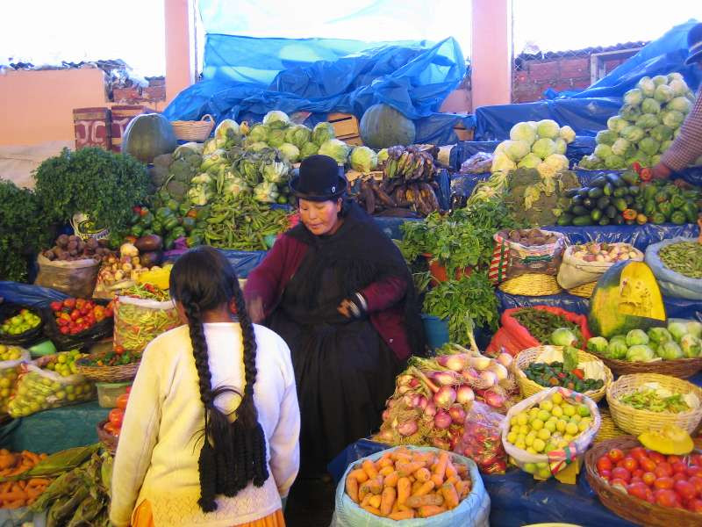

On hill above Copa.
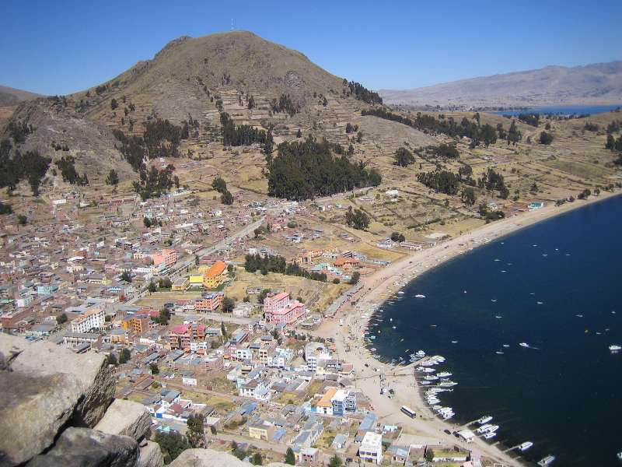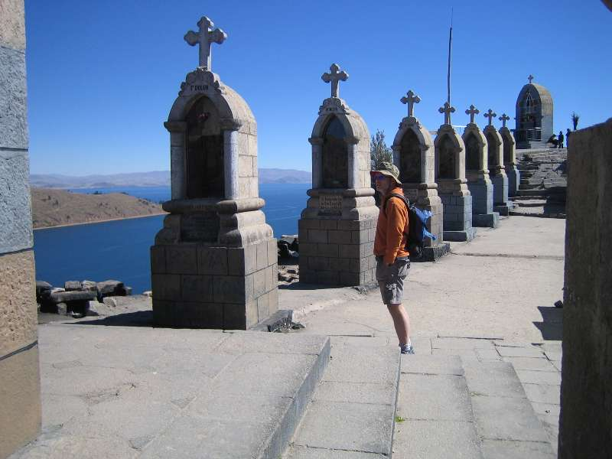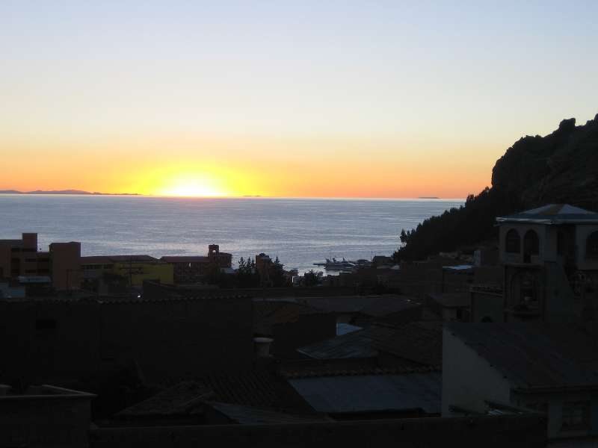

17 km walk around “coast” of lake (highest in world about 3500m)
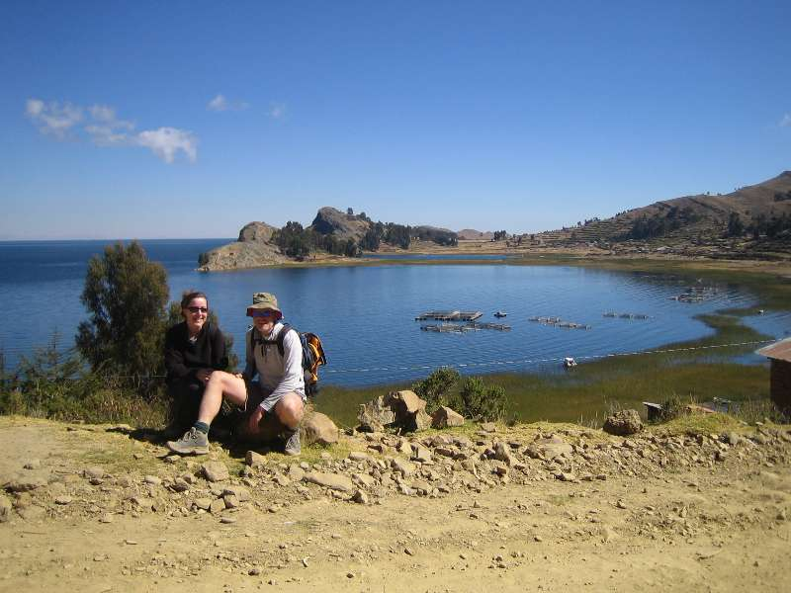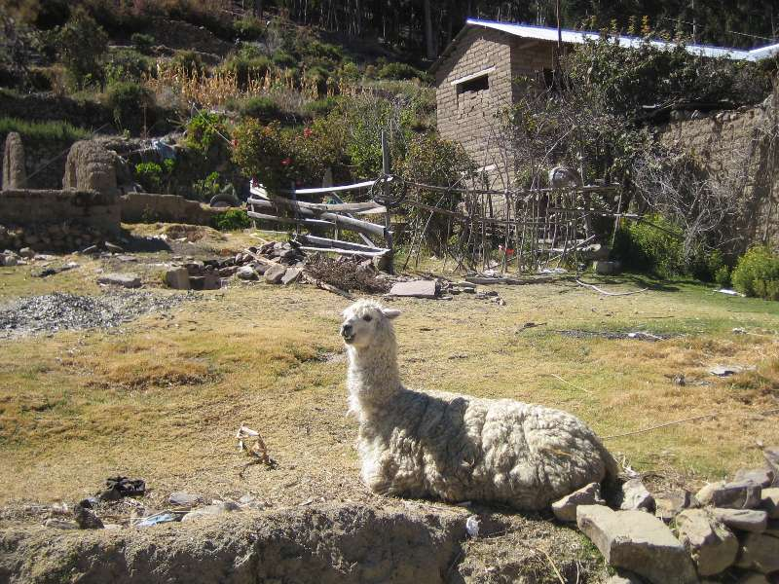

“Ferry” to Isla Del Sol, birth palce of Inca-ship-ness.
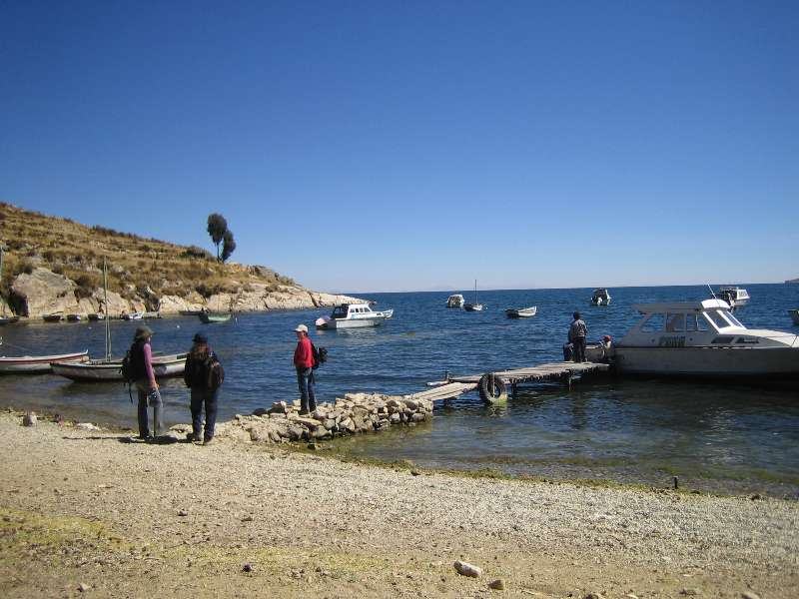

More Andees in background.
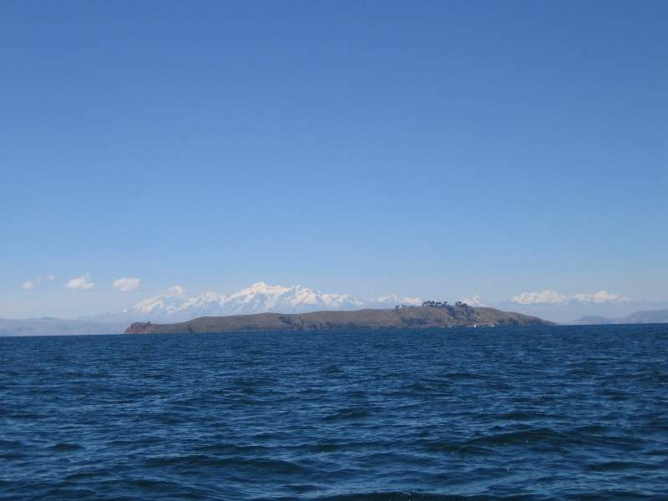

As soon as arived, had to leave as no boat back Hill manyana otherwise. Badly planned.
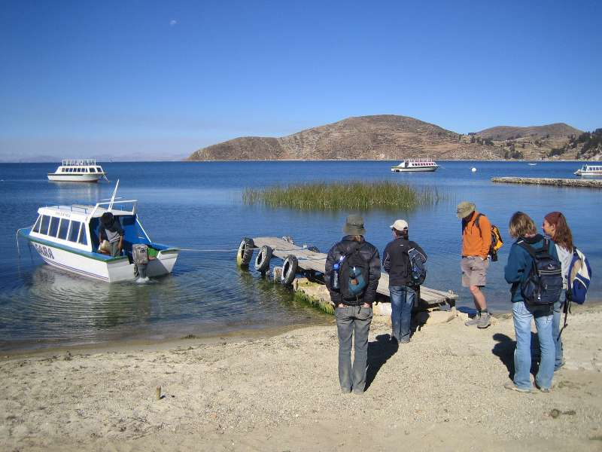

Copa reataurant specialise in local trout which is xlent.
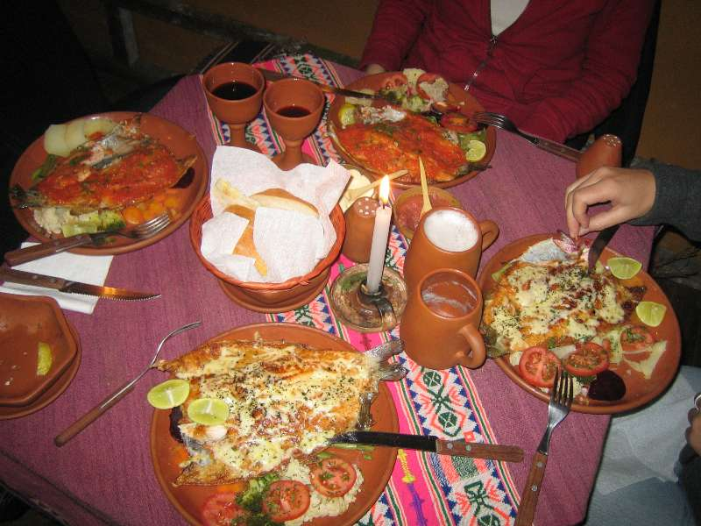

Leaving Copa. Note oversized sugar-puffs, local snack.
